**Project Title:**   
Event Management System

**Abstract:**

The Event Management System is a web-based application designed to facilitate seamless event planning and booking for customers. It provides an interactive platform where customers can explore services, customize events, book event services, and make payments. Administrators can manage the gallery and oversee customer interactions. The system ensures smooth event management operations by integrating user-friendly modules for login, event customization, booking details, and secure payment methods (credit and debit cards). Developed using Python, Flask, and MySQL, this system streamlines event planning and enhances user experience.

**Introduction:**

Event planning and management involve numerous tasks, including service selection, booking, and payment processing. Manual processes often lead to inefficiencies, mismanagement, and delays. The proposed Event Management System offers an automated solution that allows customers to browse available services, customize their events, and make online payments conveniently. The system benefits both customers and administrators by simplifying processes and improving operational efficiency.

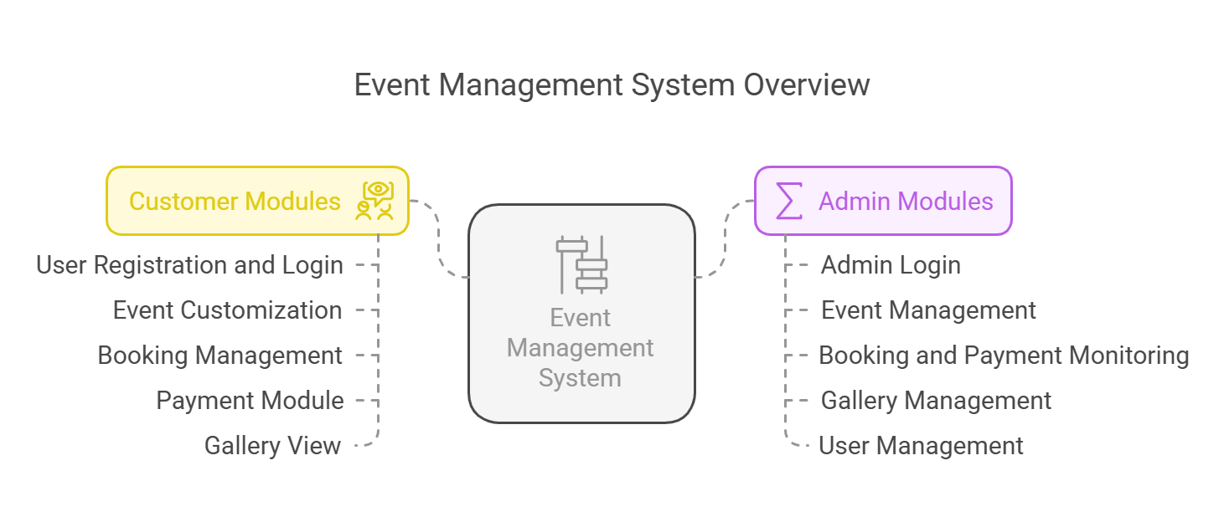

**Problem Statement:**

Traditional event management methods involve extensive paperwork and manual coordination, making them time-consuming and error-prone. Customers face difficulties in accessing services, customizing events, and making payments efficiently. Additionally, administrators lack an integrated platform to manage event-related services effectively. The need for a digital solution that centralizes event planning operations is crucial to improve user experience and system efficiency.

**Existing System and Disadvantages:**

**Existing System:**

* The current event management process is largely manual or semi-automated.
* Customers rely on phone calls or in-person visits to inquire about services.
* Event customization options are limited and unorganized.
* Payments are primarily cash-based or require bank transactions.
* Administrators manage bookings manually without real-time tracking.

**Disadvantages:**

* High chances of miscommunication between customers and service providers.
* Lack of real-time updates on event availability and booking status.
* Inefficient payment processing leads to delays and potential fraud.
* Difficulty in managing event galleries and customer records.

**Proposed System and Advantages:**

**Proposed System:**

The proposed Event Management System automates the entire event planning process by offering a web-based platform where customers can:

* View available event services.
* Customize their event requirements.
* Book events and make payments online.
* Track their event bookings in real-time.

Administrators will have control over gallery management and customer interactions, ensuring smooth operations.

**Advantages:**

* Provides an easy-to-use interface for customers to explore and book services.
* Enhances efficiency with real-time updates on event bookings and availability.
* Secure online payment options (credit and debit cards) ensure smooth transactions.
* Reduces administrative workload by automating service management.
* Improves customer satisfaction through better service customization and instant booking confirmations.

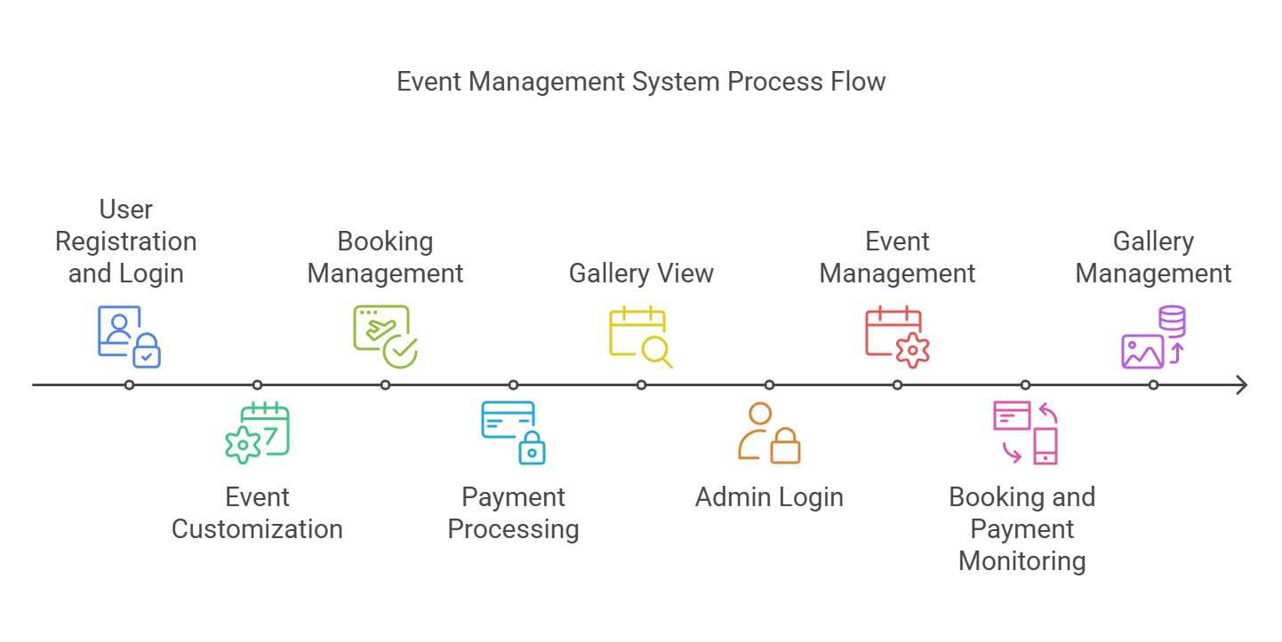

**Modules:**

**Customer Modules:**

1. **User Registration and Login:**
   * Customers can create accounts and log in securely.
2. **Event Customization Module:**
   * Customers can select services and customize their event preferences.
3. **Booking Management:**
   * Customers can book event services, view their booking history, and track ongoing bookings.
4. **Payment Module:**
   * Customers can securely pay using credit or debit cards.
5. **Gallery View:**
   * Customers can browse past event images and services offered.
6. **Logout Module:**
   * Ensures secure user logout functionality.

**Admin Modules:**

1. **Admin Login:**
   * Administrators can log in securely to manage the platform.
2. **Event Management:**
   * Admins can add, update, and remove event services.
3. **Booking and Payment Monitoring:**
   * Admins can view and manage customer bookings and track payments.
4. **Gallery Management:**
   * Admins can upload and update event images in the gallery.
5. **User Management:**
   * Admins can manage customer accounts and control access.
6. **Logout Module:**
   * Ensures secure logout functionality for administrators.

**Software and Hardware Requirements:**

**Software Requirements:**

* **Programming Language:** Python
* **Framework:** Flask
* **Database:** MySQL
* **Frontend Technologies:** HTML, CSS, JavaScript

**Hardware Requirements:**

* Processor: Intel Core i3 or higher
* RAM: 4GB or more
* Hard Disk: Minimum 100GB storage
* Internet Connection: Required for web hosting and online payments

**Conclusion and Future Enhancement:**

**Conclusion:**

The Event Management System provides an efficient and user-friendly platform for customers to plan and book their events effortlessly. By integrating event customization, gallery management, and secure payment processing, the system enhances the overall event planning experience. Administrators can efficiently manage bookings, making the entire process seamless.

**Future Enhancement:**

* Integration of AI-based event recommendations for customers.
* Implementation of chat bot support for real-time customer queries.
* Addition of a mobile application for enhanced accessibility.
* Expansion to include vendor management for event supplies and catering services.
* Incorporation of block chain technology for secure transactions and data integrity.